Success Stories FY17
Feed the Future Zambia Mawa project
The SILC-PSP Model improving PSPs’ Living standards.
Paul Kasaro is a Savings and Internal Lending Communities (SILC) Private Service Providers (PSPs). Over the course of a year he successfully passed the selection, training and rigorous testing process, proving he could provide high quality services to savings groups and earn a fee for his services: he graduated to become a PSP in April 2016. He resides in Zibulo Village which is located about 74 Km from the main business Centre in Lundazi district.
Paul is 39 years of age and married to two wives with a total of eight children. The four children from the first wife are all girls and in school, while the other four children from the second wife comprise two boys and two girls and they are all in school. Only one first born girl child from the second wife is in high school currently doing grade eight, while the rest are at primary school level, in grades ranging from one and seven. Paul himself stopped school in grade nine at Emusa Basic School (now Emusa Day Secondary School) due to failure to pay school fees when his father passed away. He never imagined he would put eight children through school.
Before joining the Mawa project as a Field Agent (FA) in April 2015, Paul’s main source of income was subsistence farming and a retailing through a makeshift roadside store. His income could however not meet all his household needs. At community level, Paul worked as a volunteer board secretary at a local Kambeteka Farmer Cooperative Society from 2010 to 2014 without any form of payment. Although he did not have full information on the operation of the SILC-PSP strategy and its benefits, Paul was motivated to take up the challenge and opportunity to work as SILC FA after attending a village SILC sensitization meeting conducted in his community by the Mawa project in 2015. He was, however, convinced the SILC-PSP methodology provided a great opportunity for his community to learn how to save and manage their finances to improve their household business outcomes and their general welfare.
The SILC-PSP methodology is a form of a Savings-led microfinance model or program that was implemented under Mawa project were a PSP facilitates the self-selection process of community members who come together to start making small saving periodically as a SILC group
A SILC group is a savings group open to both men and women. They usually meet every week of the month to save. Members save at every meeting and take out loans from that capital which they repay with interest. After about a year, members share out all the money that has accumulated over the period. Every member gets back their savings plus a profit made through loans. Every member is free to use their share amounts to meet their own various goals. Financial goals are set at the beginning of the cycle so that members save for a clear purpose and keep that focus in mind. Members are encouraged to discuss their goals with the whole family to ensure all financial needs and opportunities are considered.
When Paul finally became a SILC PSP after eight months of intensive training and mentorship in the various aspects of the SILC -PSP methodology and Skills for Marketing and Rural Transformation (SMART skills), he began to train and support SILC groups independently earning a fee from the groups, rather than the project, in exchange for his services. He has managed to grow his groups from six, when he was still an FA, to fourteen. As a PSP, his job includes marketing his SMART skills services and sensitizing communities about the benefits of SILC helping to organize them into SILC groups until they can manage on their own; and they pay for that service.
Apart from the SILC methodology, the other SMART skills offered on demand by the PSP include Financial Education (FE), Market and Basic Business skills (MBB) and Selection, Planning and Management of IGAs (SPM).
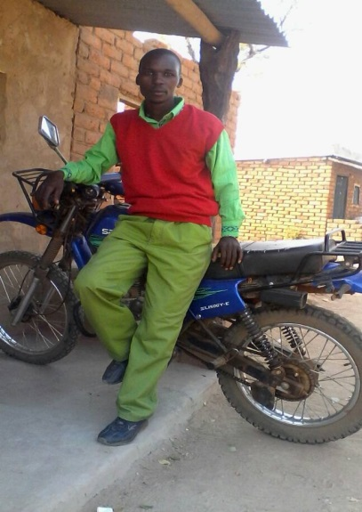
Since Paul became a SILC PSP, he earns an average of ZMK 350.00 (37 USD) per month through trainings and support services in SMART skills and SILC methodology which he provides to the groups. This translates into 75% above what he used to get per month in project stipends. He makes extra money through share-out support services where he earns an average of ZMK100.00 (10 USD) for each group share-out supported. For the one and half years that Paul has worked as PSP, he has managed to start a piggery business and bought a motor bike to ease his movements in supporting his groups. In addition, he was able to procure an increased number of seed maize and inorganic fertilizers for the 2016/17 farming season and produced over 150 fifty Kilogram bags of commercial maize. He has already sold 80 of the bags at ZMK60.00 (6 USD) per bag to government Food Reserve Agency(FRA) and awaiting payment. He is currently holding the remaining 70 bags in anticipation of improved buying prices. Unlike in 2015/16, the massive bumper harvest recorded in the 2016/17 farming season in Zambia has negatively affected the buying price of most farm commodities as most farmers were not able to sell their farm produce at a good profit margin. This is against the background that the cost of major farm inputs such as seeds and fertilizers has been prohibitively expensive.
Paul's SILC group support work made easier with purchase of a motor bike.

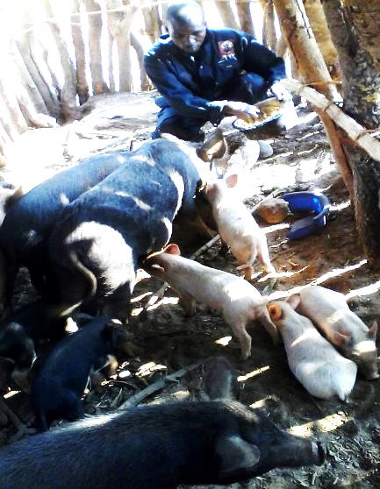
Despite this seasonal challenge Paul boasts about the many tangible benefits to his group members and himself. He says, “Before I became a PSP, I knew nothing about the benefits of SILC. But now I have managed to pay for all my eight children’s school fees and related school requirements. I am also running a successful piggery business venture. My overall standard of living has totally changed, though some community members are feeling jealousy of my progress. These are people who are not in SILC groups. There is no hunger in my home and my group members are equally doing very fine. They have bought various livestock such as cattle, pigs, goats and others have made home improvements and are very food secure. They are no longer waiting for government’s Farmer Input Support Program (FISP) subsidized seed and fertilizers because they are now able to afford them through their yearly share-outs.”
Paul feeding his pigs at his farm

A PREPARED MOTHER PREPARES FOR HER CHILD START OF COMPLIMENTARY FEEDS.
Teresa Banda lives in Chiteu village of Chief Misholo area, Chipata. Teresa is the mother of five-month-old Phillip Tembo. She is breastfeeding him exclusively for the first six months but is already preparing for the changes that will come when he needs complementary feeding. She decided to prepare in advance the pre-mixes that her child will require as he is introduced to solid food. Teresa’s household has been receiving nutrition lessons from Annie Banda their nutrition volunteer from the time she had her first child who has since been graduated and she is growing up healthy and strong. What motivated Teresa to make the pre-mixes for her child was the positive experience she has had with her first child when following Mawa’s recommended practices. “I had less problems with my first child than some neighbors because of the lessons that I was receiving from Mawa through the nutrition volunteer. I had experienced less illnesses and other complications that affect the welfare of the child and I say so because my neighbors who were not receiving the lessons experienced more problems than me.” For Teresa planning in advance was very important because of differences in food availability each season which in turn affects the supply and availability of food. She decided to make the pre-mix during this post-harvest period when her family has a good supply of groundnuts harvested this year. She also said “I have dried some pumpkin leaves by following the specified recommendations of Mawa by drying in the shade and very soon I will pound some dried vegetables for my baby Philip to ensure that he eats balanced diet porridge. Teresa was found with the ingredients in the picture below ready to make a premix for her baby.
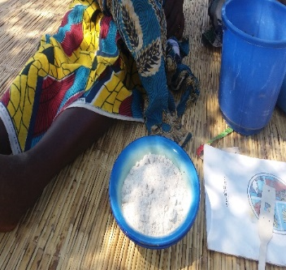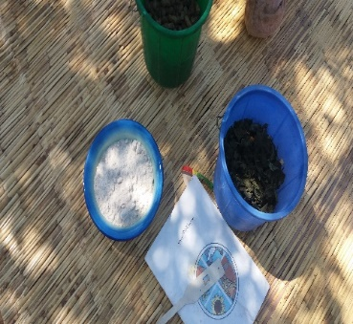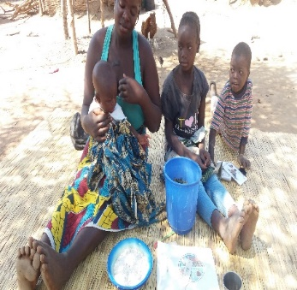
Teresa’s ingredients to make a porridge pre-mix: pounded groundnut, maize meal (on the blue plates) & dried pumpkin leaves (in the blue bucket). Photo by Trust Malabanyika,19th July 2017.

Teresa Ngoma also understands the importance of consuming animal proteins and as such her family has decided to keep chickens so that eggs will be added to baby Philip’s porridge. She further indicated that practicing what she learns from Mawa has been easy due to the support she receives from her husband Mr. Daniel Tembo. The support she receives was prompted by the positive results they have been experiencing from the time she started participating in Mawa. They setup a place where their chicken could lay eggs to support the household’s dietary needs.
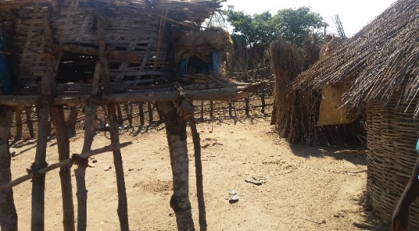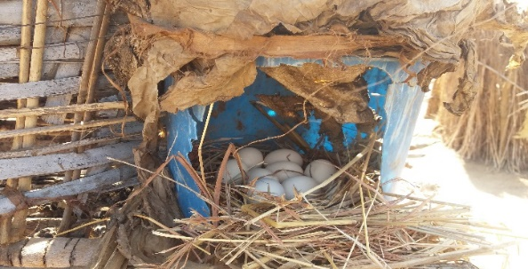
Teresa’s chicken pen at her home in Chiteu village in Chipata. Photo by Trust Malabanyika, 19th July 2017

